DEPARTMENT OF BOTANY


ECO CLUB
ACADEMIC YEAR-(2025-26)

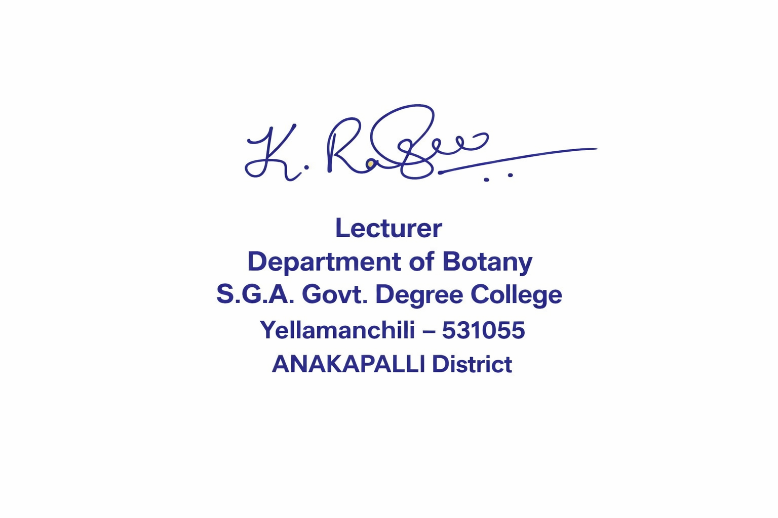
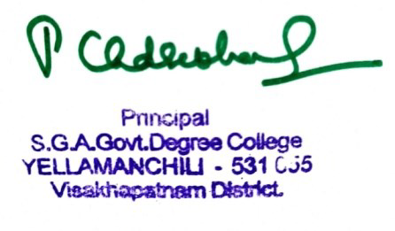

Signature of the HOD Signature of the principal


DEPARTMENT OF BOTANY
MICRO IRRIGATION SYSTEM
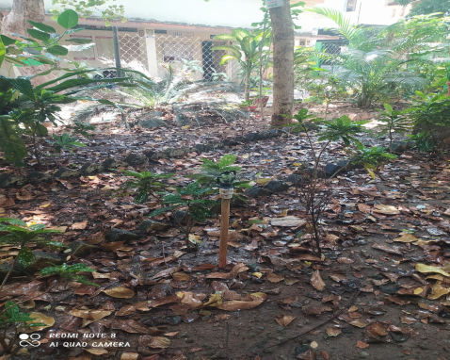
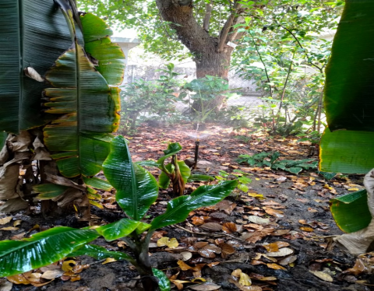

DEPARTMENT OF BOTANY

PREPARATION OF VERMICOMPOST BY STUDENTS
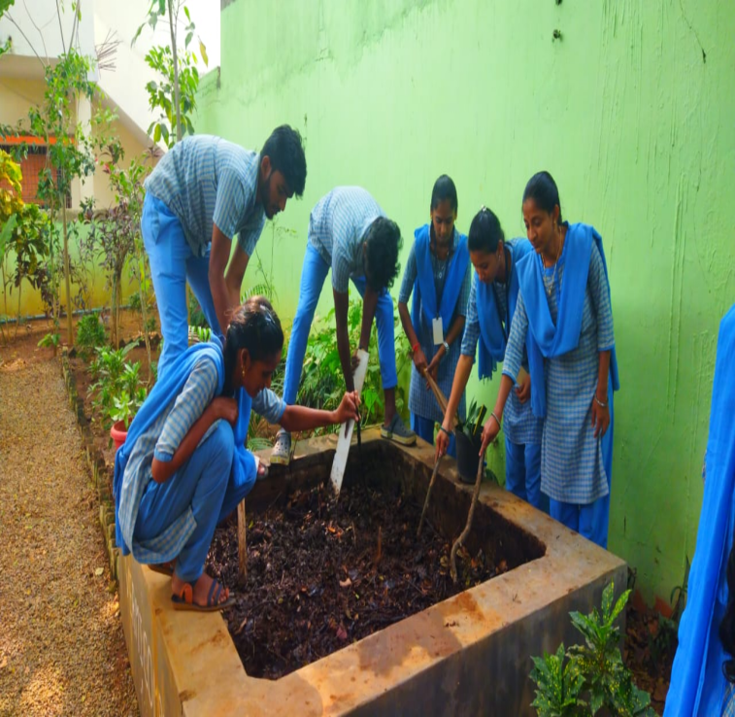
DEPARTMENT OF BOTANY
BOTANICAL GARDEN CLEANING BT SEM IV STUDENTS
27-Oct-2025
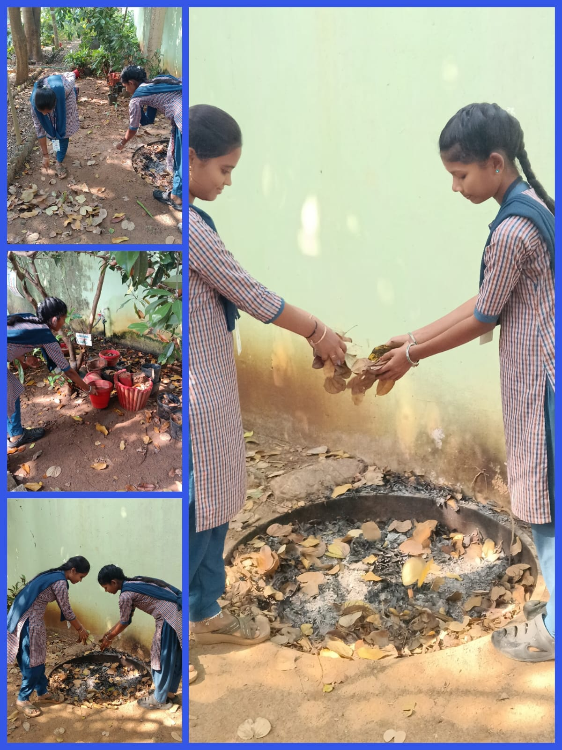

DEPARTMENT OF BOTANY
Plant watering by II AND III YEAR STUDENTS
(21-JAN-2026)
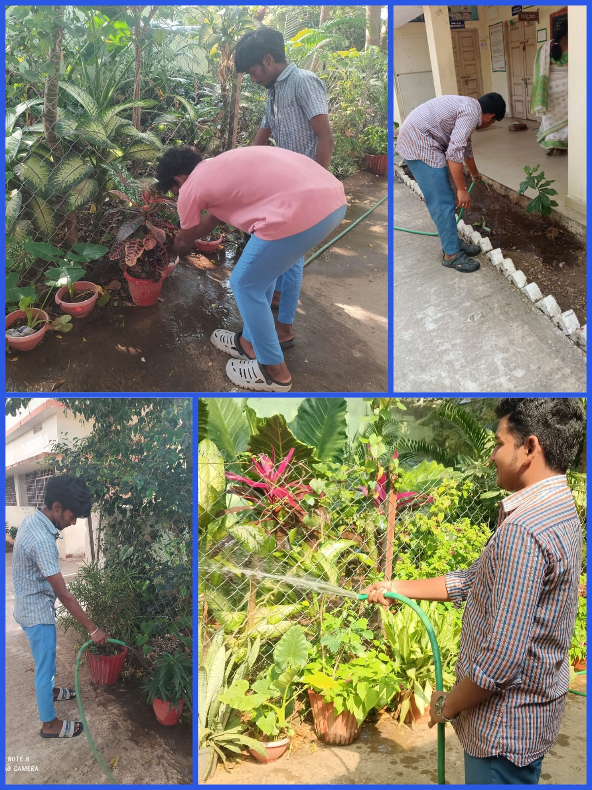
DEPARTMENT OF BOTANY
Mirabilis jalapa seeds- plantantion by Vallika Sem-IV
(02-03-2026)
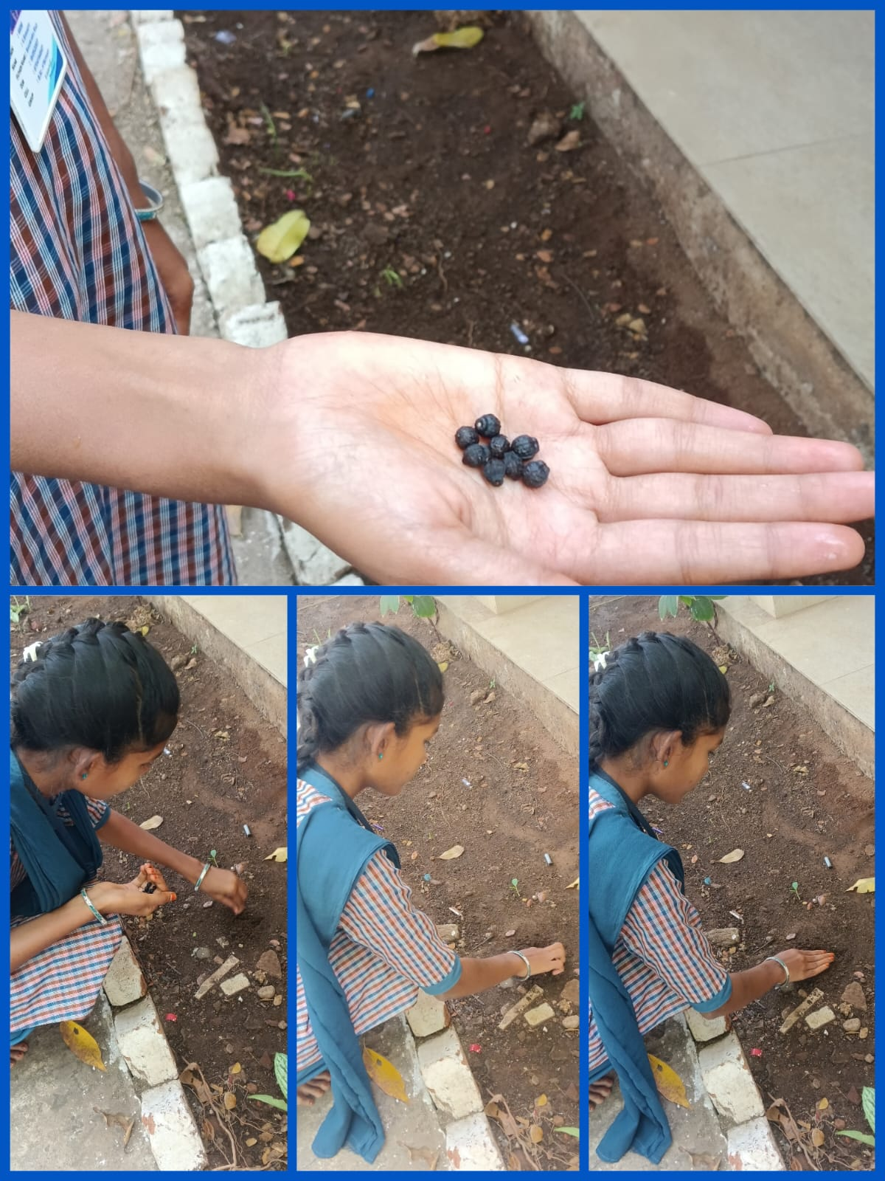

DEPARTMENT OF BOTANY
DEPARTMENTAL CLEANING
3RD SATURDAY OF FEB-2026
